### Responsiveness testing

|  |  |  |  |  |  |
| --- | --- | --- | --- | --- | --- |
| No. | Test Title | Pre-Condition | Test Steps | Expected Results | Actual Results |
| 01. | Testing for large screen or website | Opening the system in the testing browser of a desktop pc. | logging in to the system and open the home page. | The test result was as expected. | As expected. |

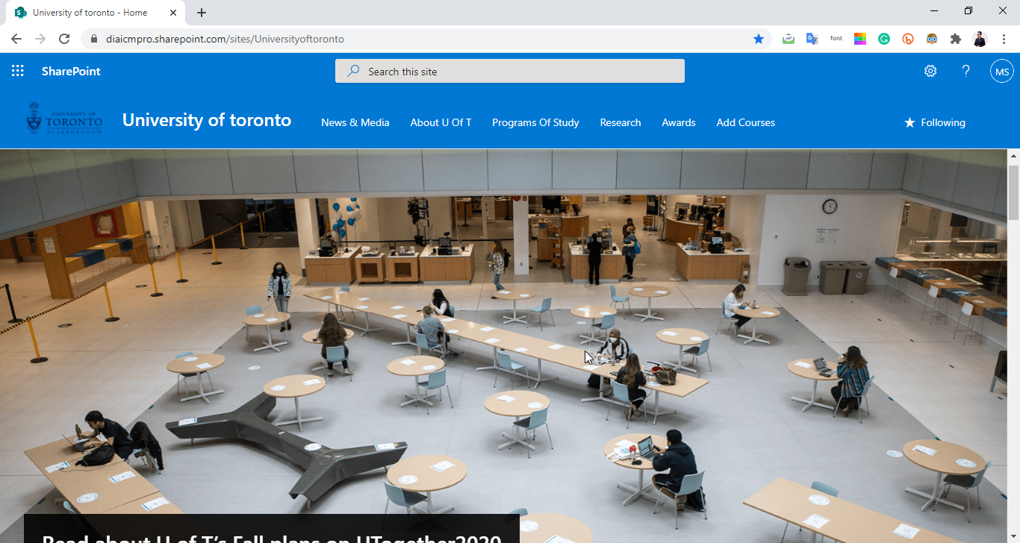

|  |  |  |  |  |  |
| --- | --- | --- | --- | --- | --- |
| No. | Test Title | Pre-Condition | Test Steps | Expected Results | Actual Results |
| 01. | Testing for mobile screen. | Opening the system in the mobile view browser. | logging in to the system and open the home page. | The test result was as expected. | As expected. |

